Benchmarking single-qubit gate with 99.99% fidelity via pulse shaping in silicon spin qubits

Akito Noiri1, Yi-Hsien Wu1, Leon Camenzind1, Patrick Bütler1, Kenta Takeda1,

Takashi Nakajima1, Takashi Kobayashi1, Ik Kyeong Jin1,

Giordano Scappucci2, Seigo Tarucha1

1RIKEN

2QuTech and Kavli Institute of Nanoscience

Implementing fault-tolerant code is essential for achieving large-scale quantum computing. To implement fault-tolerant codes, we need qubits with gate operation fidelity above a certain threshold, usually 99%, under a common decoding scheme. Improving this gate fidelity will reduce the number of physical qubits required to achieve the same logical error rates.

Here, we investigate the fidelity of single-qubit gates for five qubits in Si/SiGe quantum dots with a micromagnet. We compare single-qubit gates with different control pulses and achieve single-qubit gate fidelities >99.99% with a Kaiser envelope pulse for all qubits consistently (Figure 1). We investigate the effect of driving speeds and interval times on the gate fidelities with both rectangular and Kaiser shaped pulses.

We also find that the shaped envelope pulse improves fidelity of simultaneously driven single qubit gates. These ultra-high-fidelity gates will improve the prospect of implementing fault-tolerant codes with silicon spin qubits.

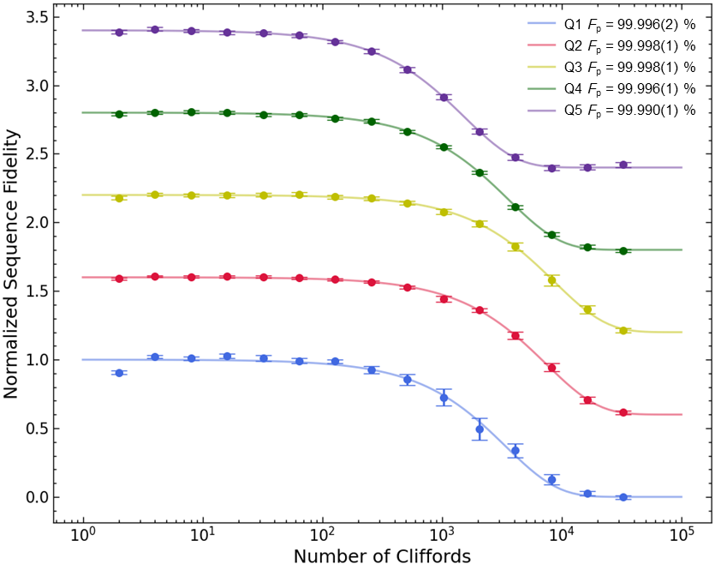

Figure , Randomized benchmarking results of single-qubit gate for the five qubits.